Kaiserstand Bracket
Version 3.0

Project Goals
Create an easy to install and easy to remove bracket for Kaiser Stand
My model is RS2 XA
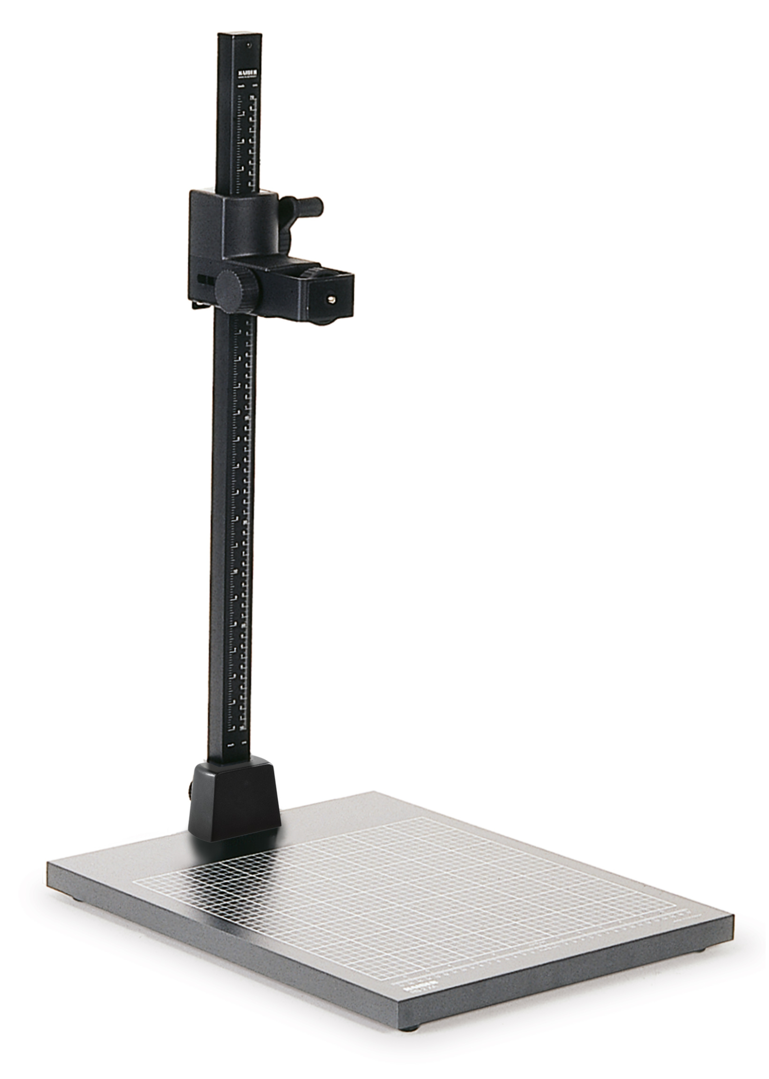

Drawings
Back size: 76x44 mm
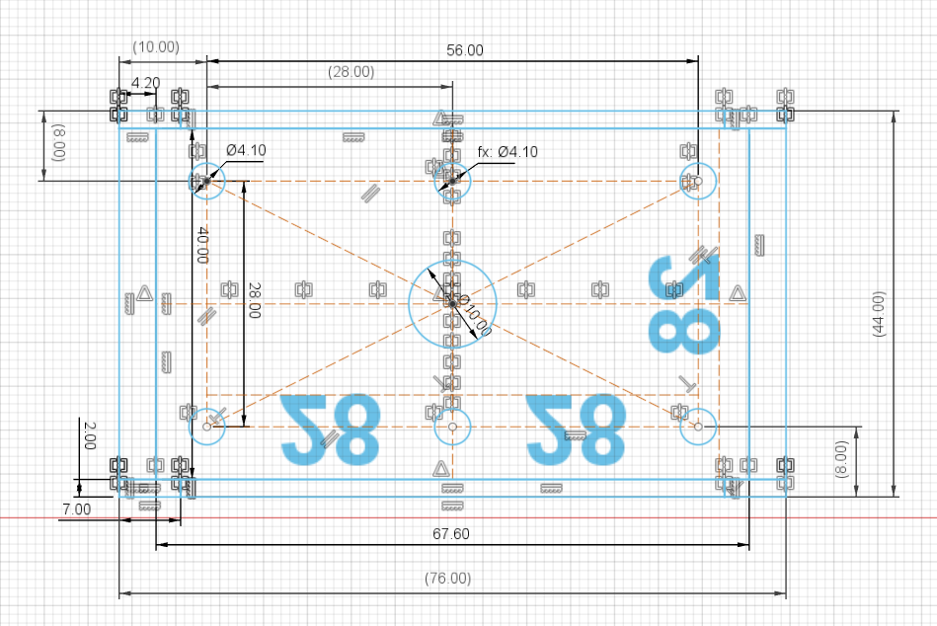

Side view
Basic dimensions: 44 x 90 mm
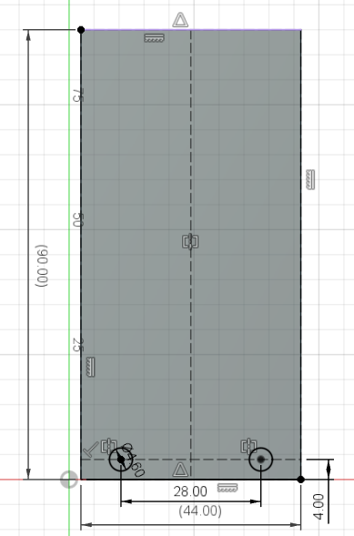

3D Rendering

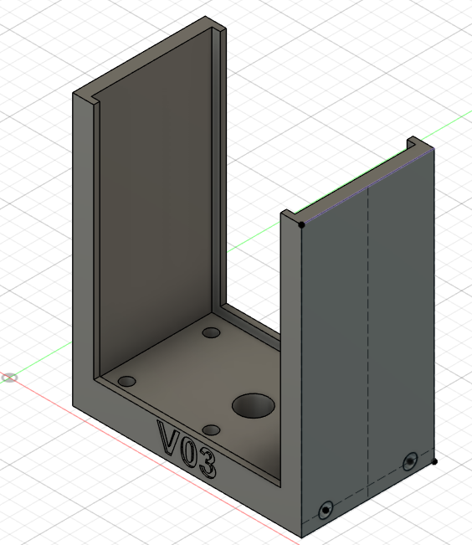

Pictures

Kaiser mounting plate
Holes are on a rectagle 50 x 30 mm
I use Heat Set Inserts so the thread is M3

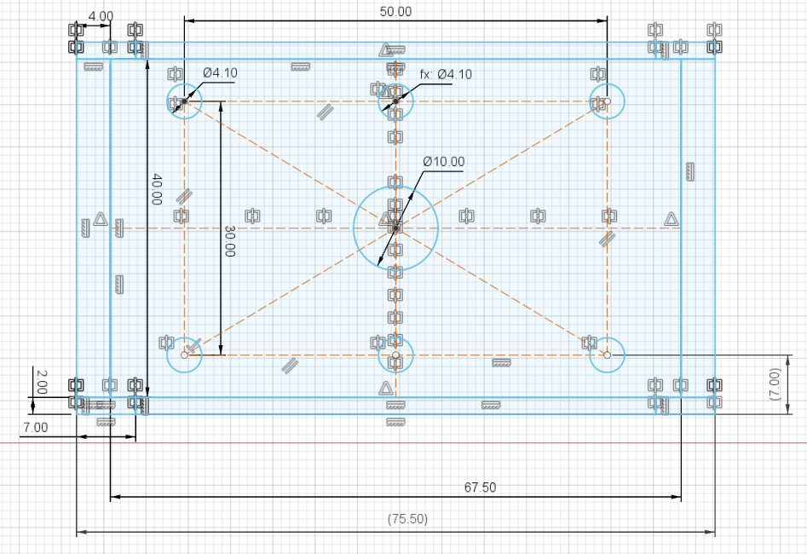

3D Rendering
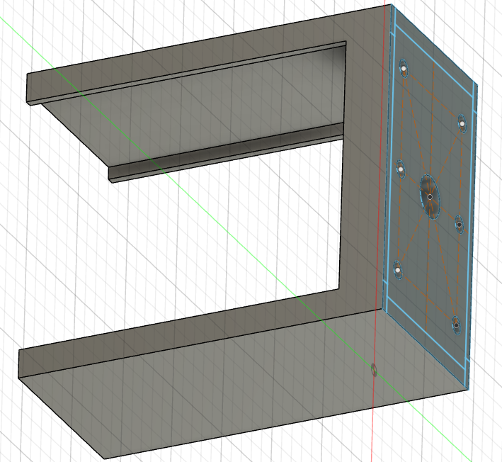

Printer layout
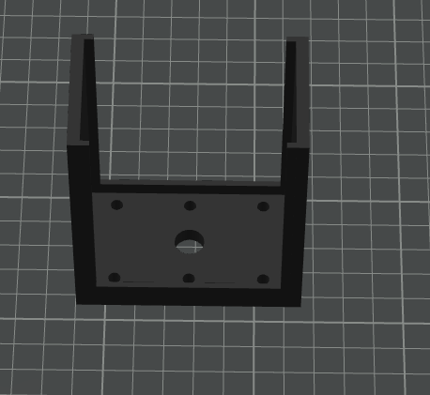

Images
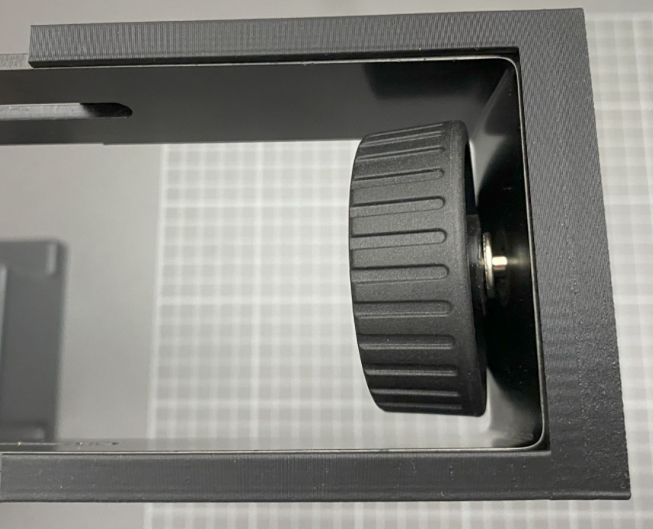 | 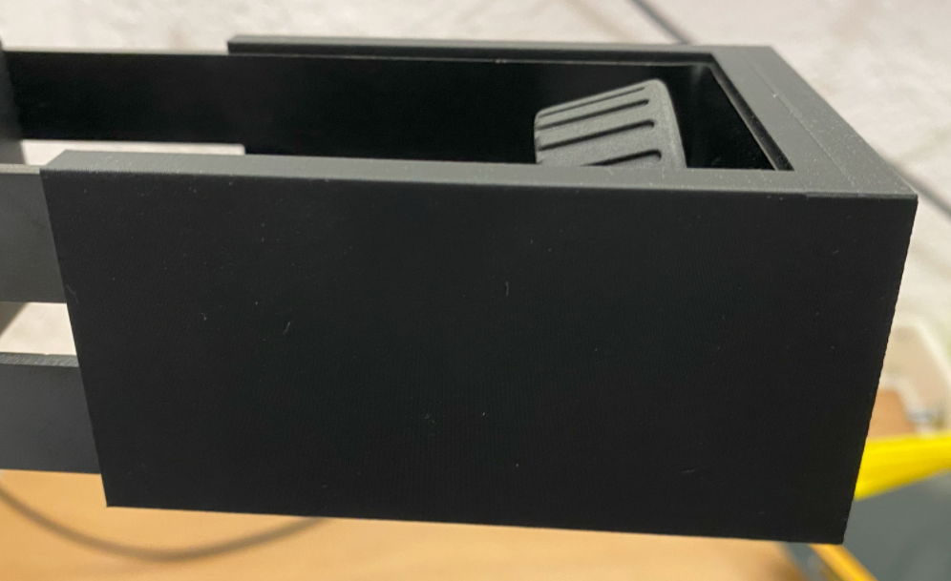
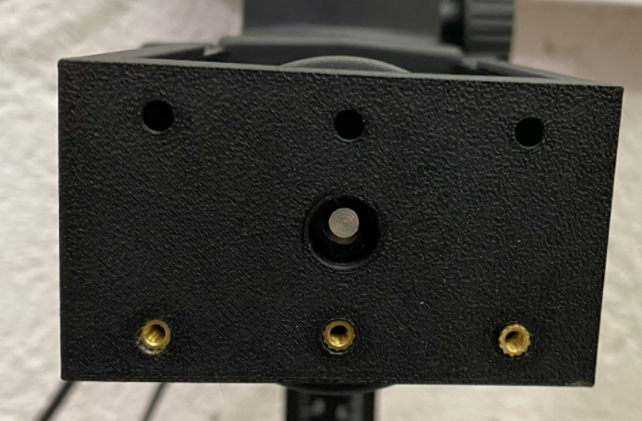

For the next Iteration
Add 4 holes for M3 insert on the side of the bracket using the thickness of the head
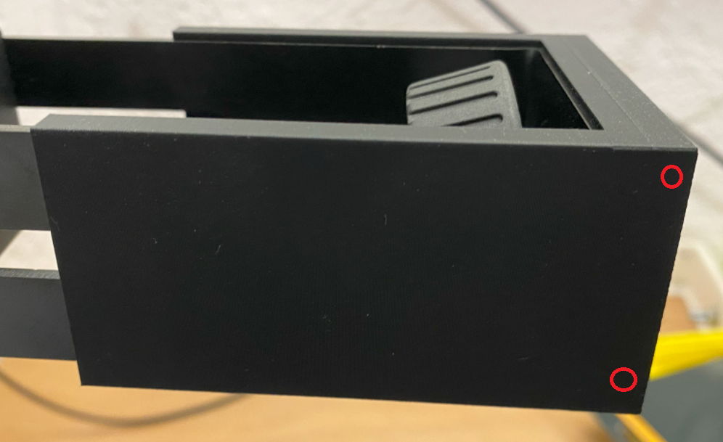

Add numbers to specify mounting distance


